DevOps

Assignment 2017

Team Polo

Andrea Cole L00115856

Cathal Keany L00115066

Conor McGinty- L00117391

Liam Whorriskey- L00113360

Eimear Mc Cann- L00105764

Maria gibson- L00105748

B.Sc. in Computing

Enterprise Applications

Assignment 2017

Health insurance On-line system to enter

Customer’s details

By

Team Polo

Andrea Cole L00115856

Cathal Keany L00115066

Conor McGinty- L00117391

Liam Whorriskey- L00113360

Eimear Mc Cann- L00105764

Maria gibson- L00105748

Requested By

Lecture: Ruth Lennon

**Introduction**

**Project Overview**

This project has been developed by Group2 Team Polo for an Assignment in DevOps at Letterkenny Institute of Technology.

The system has been developed for a health insurance company, enabling customers to use this on-line system to enter their details. This system is designed to calculate the risk and produce a cost of insurance for client. This is a secure system that’s takes into account personal details and private health information and foreign travel. The administrator has full access to edit details, however once client has entered details no further access is necessary.

Development has occurred over a number of weeks individually at home and through sessions together in study rooms on a weekly basis these were scrum style Stand-up meetings to critic progress. Working as a team the specification was framed. As the project progress Jira was used to progress and track work load. Github was used to push documentation and upload code.

Throughout this document there shall be an insight into the system, employed development methodologies and overview of the team co-operation and implementation.

**Scrums**

First Scrum meeting Use case and State diagrams for health Insurance project were drawn.

All team members were present and participated input. Results are as follows: 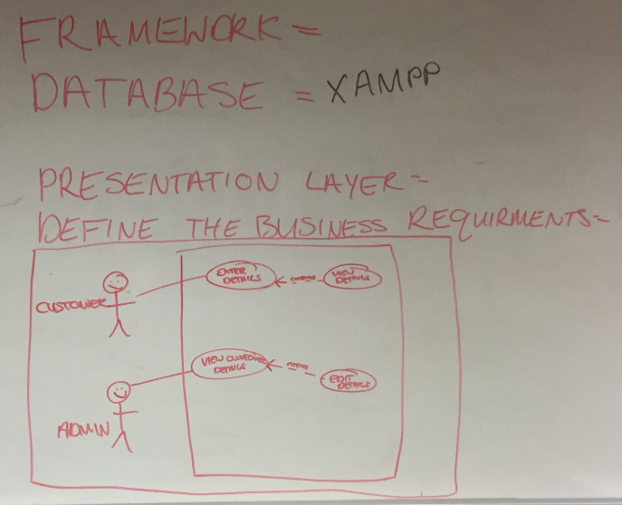

**Fig 1 Use Case Diagram Customer**

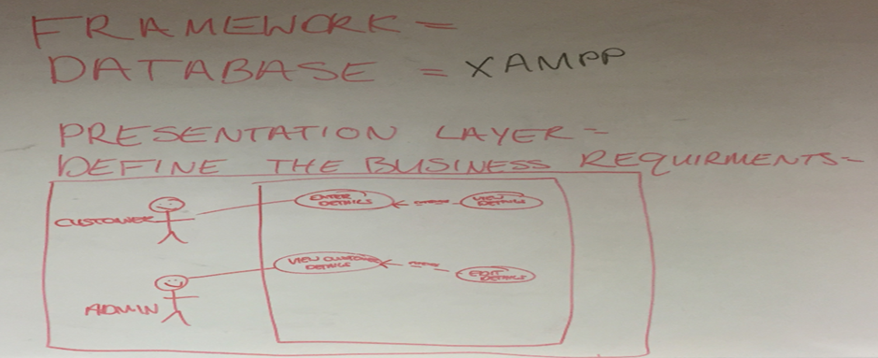 **Fig 2. Use Case Diagram Administrator**

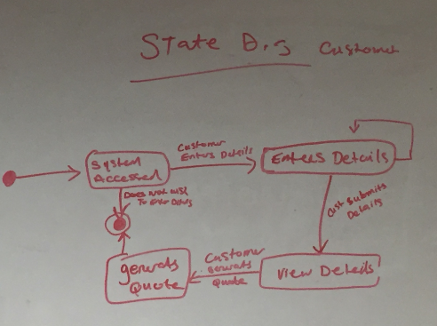

**Fig 3. State Diagram Customer**

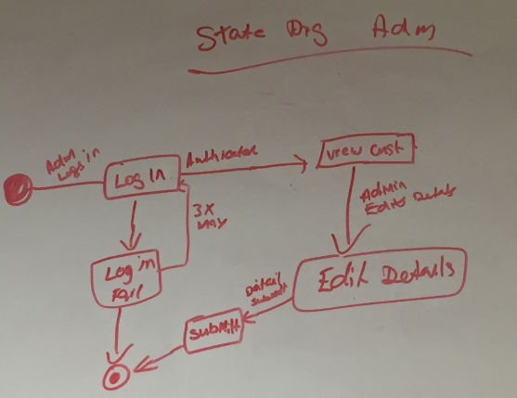 **Fig 4. State Diagram Administrator**

**Summary**

Research was conducted into application design, testing, database development and web application. Results will highlight reason for chosen path in conducting this project. Java connection has now been requested for by Customer.

**Technical description of project**

* *Hardware requirements*

The software as this would have the Database and Administration Functionally installed on the Health Insurance Company’s IT infrastructure. The Customer Web application development.

* *Software*

*(To Do)*

* ERD/Class Diagram- (To Do)
* Tables- Please see appendix

**Methodology (SDLC)**

The team decided to implement a proto-type Development Life-Cycle. This was chosen to allow the team to branch off with a number of team members working on Web development, App frontend and Database creation.

**Application Design**

**Research into software of web application testing**

1. JWebUnit - Tests web applications. Can be associated with selenium
2. Selenium - Automation testing of functionality.
3. LoadRunner - Load testing. Tests web application with a heavy load.
4. Qtest – Web loading testing tool.
5. TestComplete – Automation testing.
6. Katalon – Is used alongside Selenium.

From researching the different software, in my opinion JWebUnit and Selenium are the most efficient for the project.

**Database Design**

Reasons for using an SQL database for Project

1. **High Speed**.

SQL queries can search and fetch high volumes of data from database in a quick and efficient manner.

1. **Easy to Manage**

Using standard SQL means it is easy to manage the database without the need for a lot of coding.

1. **Supports OOP**

SQL can support and communicate with object orientated programming which makes it flexible when using it in a database for applications.

1. **Compatibility**

SQL Database can be used with Bootstrap which is the open source front end framework selected for the online application.

An rds database has been created on AWS by Eimear on her aws account.

Hosting it on the cloud made it easier for both to work on the database.

Access connection to the database on SQL workbench paste the following - *devops.cyivwen45nzy.us-east-2.rds.amazonaws.com*

Into the host section when setting up a new connection.

Use port 3306.

The password is grouppolo

Security group has been configured so anyone can access the database which is convenient for the purpose of this project

Polo Insurance Instructions

Created an SQL database for Polo Insurance on an Amazon AWS server so it can be accessed by everyone. Two sample tables were created like discussed, Customer_table, which will include Name, address, phone etc, and a Quoate table, which will include if the customer is a smoker or travels outside Europe or US and so on. These tables will be updated as we move forward as a team. Please use the following Hostname on My SQL Workbench when connecting to the database. The Log in details are noted below to allow access to the database. Any issues with this database can be updated easily so don’t hesitate to contact me through our group email or in the next sprint. Some sample data was also entered to test the database.

**UserName:** Devops

**Password:** grouppolo

1. Download MySQL work bench (.NET and Visual c++ 2015 will have to be downloaded as prerequisites).
2. + to add a new hostname and enter the hostname stated below.
3. UserName and Password will have to be entered that is stated above.

**HostName:** devops.cyivwen45nzy.us-east-2.rds.amazonaws.com

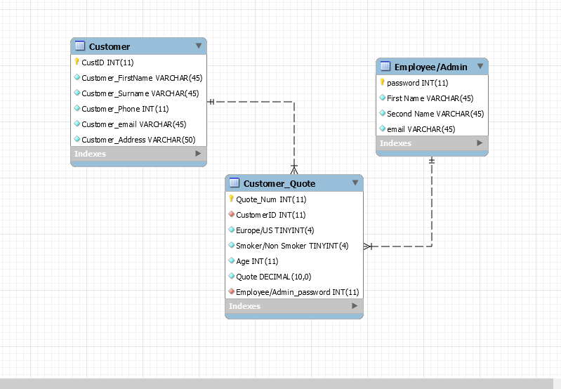

Fig 5. ERD Diagram- Revers engineered in database

**Web Development:** Liam Worskie, Maria Gibson. As Maria had no prior experience on Web Development Liam agreed to mentor Maria in web design through a series of meetings to discuss design and development.

## Research for web.

## 10 Best Reasons to Use Bootstrap for Amazing Web Designs

Initially built by a designer and developer from Twitter, Bootstrap has turned out to be one of the trendiest front-end frameworks in the whole world. Before it became open-source, Bootstrap was first identified as Twitter Blueprint. Bootstrap is responsive, mobile-first, prevailing, and front-end framework, which is developed along with CSS, JavaScript, and HTML. Bootstrap has many benefits from scratch for every web development project, and one such reason is the huge number of resources accessible for Bootstrap. If you as a web designer or web developer are new to Bootstrap, we have put forward some of the ten best reasons that will help in using Bootstrap for remarkable web designs.

**1. Easy to Use**

It is extremely an easy and speedy procedure to begin with Bootstrap. Bootstrap is very adaptable too. You can utilize Bootstrap along with CSS, or LESS, or also with Sass [after you download the Sass version].

**2. Responsiveness**

Every year mobile devices persist to grow hugely popular, and the requirement to have a responsive website has become compulsory and important too. As the fluid grid layout amends vigorously to the appropriate screen resolution, thus crafting a mobile-ready site is a smooth and easy task along with Bootstrap. With the use of ready-made classes of Bootstrap, you can recognize the number of spots in the grid system that you would like each column to engage in. Then only you can identify at whichever point you would like your columns to load in horizontal position, instead of vertically to exhibit accurately on mobile appliances.

**3. The Speed of the Development**

One of the main benefits of utilizing Bootstrap happens to be the speed of the development. While driving out a new, fresh website or application swiftly, you should certainly reflect upon utilizing Bootstrap. Instead of coding from scrape, Bootstrap lets you to use ready-made coding blocks in order to assist you in setting up. You can blend that along with CSS-Less functionality and cross-browser compatibility that can give way to saving of ample hours of coding. You can even buy ready-made Bootstrap themes and alter them to fit your requirements, for gaining the quickest potential route.

**4. Customizable Bootstrap**

The Bootstrap can be customized as per the designs of your project. The web developers can make a choice to select the aspects which are required which can be simply complete by utilizing Bootstrap customize page. You just have to tick off all the aspects that you do not require, such as- Common CSS: typography, code, grid system, tables, buttons, forms, print media styles; Components: input groups, button groups, pager, labels, navs, navbar, badges, pagination; JavaScript components: dropdowns, popovers, modals, tooltips, carousels; Utilities: Responsive utilities, basic utilities. Thus your custom version of Bootstrap is all set for download process.

**5. Consistency**

Few Twitter employees firstly expanded Bootstrap as a framework for boosting the consistency across interior tools. But later the Co-founder Mark Otto after understanding the actual potential released in August 2011 the first open-source version of Bootstrap. He even portrayed how the Bootstrap was enlarged with the use of one core concept- pairing of designers along with developers. Thus Bootstrap became popular on Twitter.

**6. Support**

As Bootstrap holds a big support community, you can be provided with help whenever there comes any problem. The creators always keep the Bootstrap updated. Presently Bootstrap is hosted, expanded, and preserved on the GitHub along with more than 9,000 commits, as well as more than 500 contributors.

**7. Packaged JavaScript Components**

Bootstrap approaches with a pack of JavaScript components for including the functionality that crafts it in simple way for operating things, such as tooltips, modal windows, alerts, etc. You can even leave out the writing scripts completely.

**8. Simple Integration**

Bootstrap can be simply integrated along with distinct other platforms and frameworks, on existing sites and new ones too. You can also utilize particular elements of Bootstrap along with your current CSS.

**9. Grid**

Bootstrap has the capability to utilize a 12-column grid that is responsive. It also upholds offset and nested elements. The grid can be maintained in a responsive mode, or you can simply modify it to a secured layout.

**10. Pre-styled Components**

Bootstrap approaches with pre-styled components for alerts, dropdowns, nav bars, etc. Hence, being a feature-rich, Bootstrap provides numerous advantages of using it. Hope you would have understood the above reasons so that you can easily use Bootstrap for making superb web designs for your sites!

Discussion on Layout of web design page:

|  |
| --- |
| Navigation  Header  Side Bar  Content  Quote  Footer |

**Fig 5. Web Page Design**

Prototype – Web Page Access on link192.com /http://link192.com/agents.php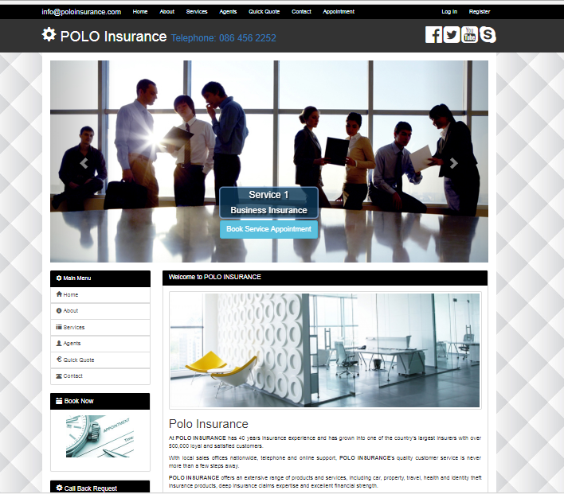

Fig 6 Home Web Page

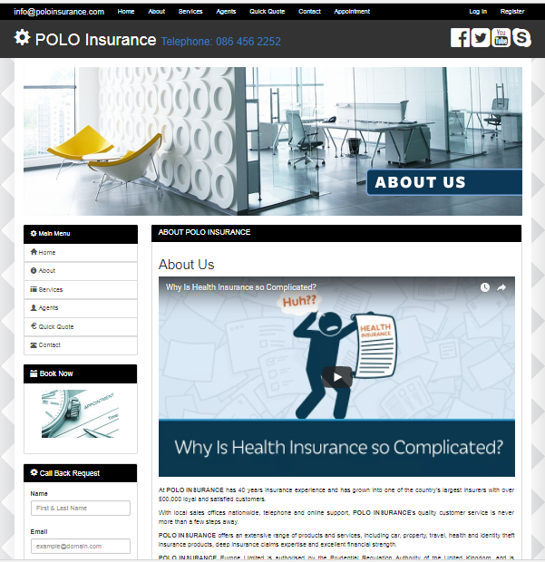

Fig 7. About Webpage

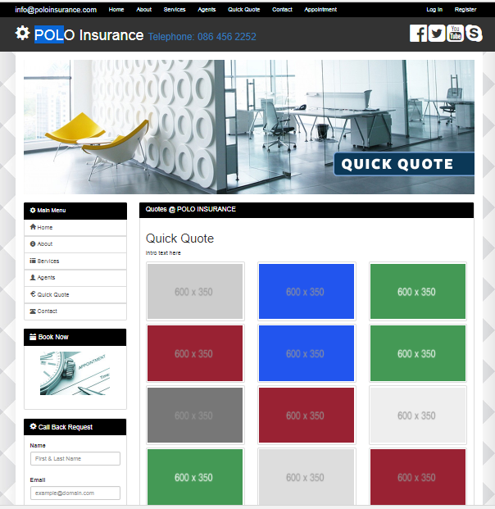

Fig 8. Quick Quote Webpage

New Proposed Contracted

Customer Meet with Polo Insurance to review new requirements. The following agreement was reached and is highlight below in fig 9.New Contract Proposal

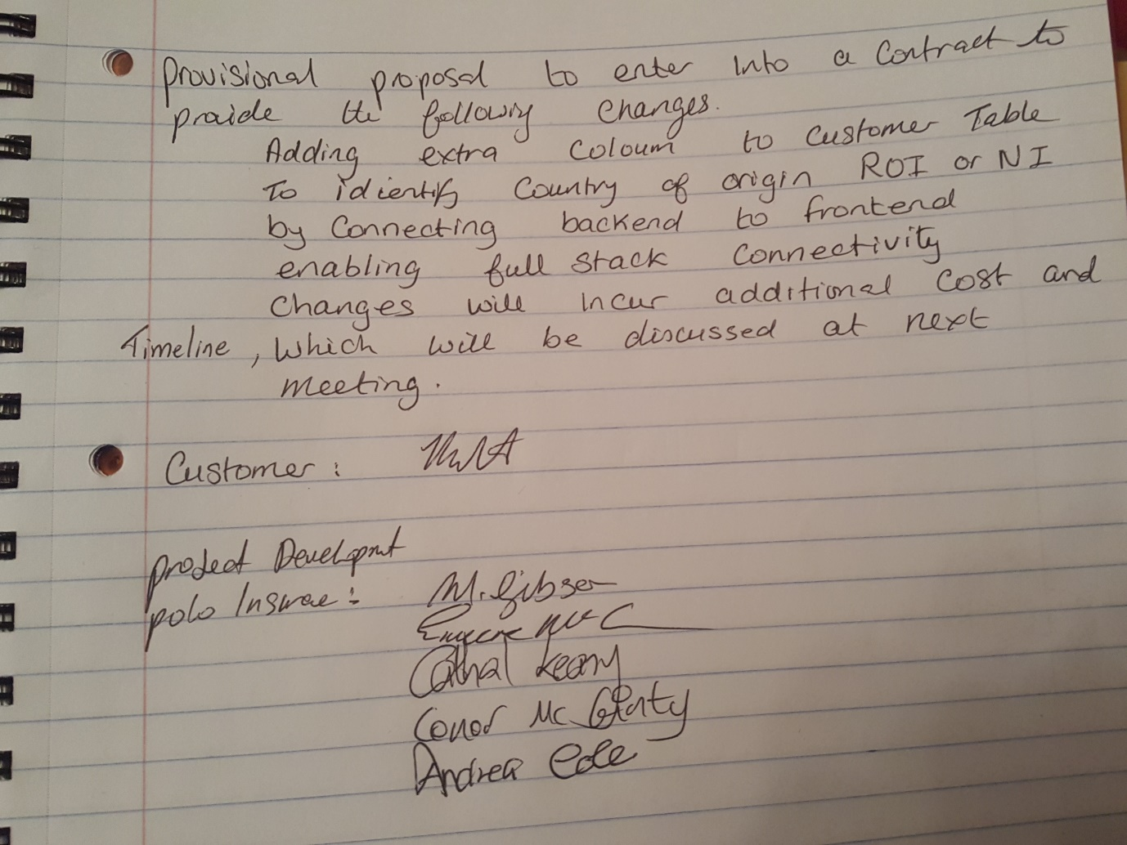

fig 9.New Contract Proposal

**Appendices**

**Sample Tables in Database**

**Table 1.1**

**Customer Table**

|  |  |  |  |  |  |
| --- | --- | --- | --- | --- | --- |
| **ID** | **Name** | **Surname** | **Address** | **Email** | **Phone No.** |
| **Primary key** |  |  |  |  |  |
|  |  |  |  |  |  |

**Table 1.2**

**Quote Table**

|  |  |  |  |
| --- | --- | --- | --- |
| **Europe/US** | **Smoker/NonSmoker** | **Age** | **65+?** |
|  |  |  |  |